

**Food**

You will need to plan your menu for your entire trip. Food needs to be easy to cook, light to carry and give you plenty of energy.

When menu planning think about:

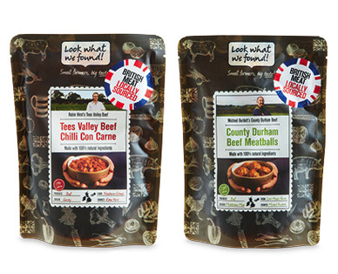1) Weight; do not bother with multiple ingredients in multiple packets. Take Boil in the Bag!

2) Durability, longevity and suitability are all must words to consider. We have seen on more than one occasion; raw eggs, fresh chicken breasts, 1kg jars of Nutella!!!

3) Calorific intake; you will be exercising all day for two days. Eat a lot and drink regularly to stay fuelled. Balance sugars with slower releasing energy foods. Haribo cannot fuel the whole expedition.

4) Emergency rations; do not eat all your food on the last day. You must keep some back in case of emergency. Your supervisor/assessor may well ask to see your emergency rations at the end. A small packet of sweets and breakfast bar are good for this.

We want you to have an easy expedition, this means camping and cooking needs to be efficient, more time setting up could mean more time in the rain. It is really easy for one person to cook whilst two set up the tent, you will be able to eat, get warm and dry in just a few minutes rather than an hour. 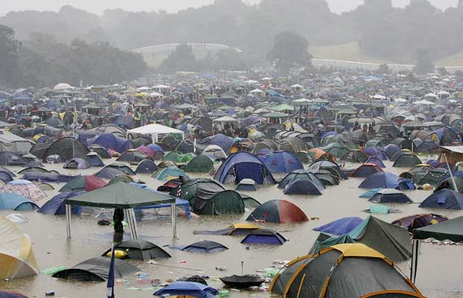

**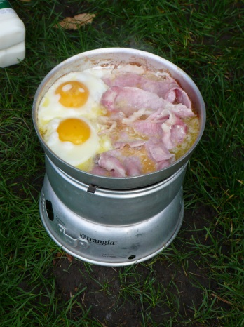*Breakfast***

You won’t have to carry your first breakfast so make it a BIG breakfast.

Having a fry up is great but the washing up can take ages if you are not a careful cook. No non-stick pans here.

***Snacks / Lunch***

Eat little and often. Keep food in your pockets and snack throughout the day. You will not be able to cook for lunch so make easy food to take with you like wraps and packets of dried fruit, chocolate and nuts.

***Dinner***

Noodles, pasta and rice all make good dinners; they are light weight, quick and easy to cook. Boil in the bag versions of food can be ready in minutes, create no washing up, generally taste pretty good and leave you with a pan of hot water to make a hot drink or soup with.

The efficiency of food is more than how long it takes to cook. How small and light it is, and how much energy you will get from eating it should also be considered. Packaging too can be a waste of space and add weight. Remove what you can where you can.

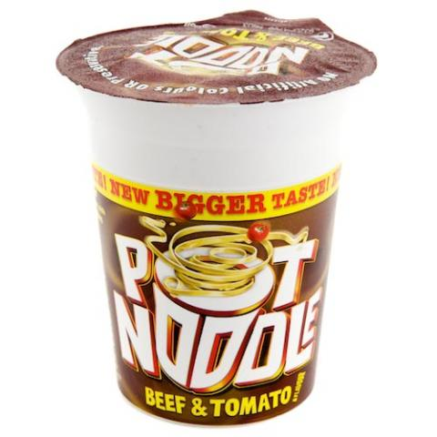

*Remember* one of your Conditions is to cook a substantial meal. Consider; Is a Pot Noodle, Substantial? An Assessor cannot sign off unless you have met this criteria.

**Water**

Staying hydrated is really important, especially when exercising. It is actually more important to drink than it is to eat. Take at least 2 litres and avoid coke/ Lucozade etc. for one weekend. One of the little juice concentrate bottles will add flavour for your whole walking group for a weekend if you need it.

# Using a Trangia

Never use a stove in a tent or try to refuel direct to a burner that appears to be out.

1. Put the stove together and check you have all components before you start. Site it on flat ground (not a table/bench) and ensure everyone has room to move around the stove.
2. Give the pans a quick rinse to remove any dust.
3. Fill the burner from the fuel bottle (well away from the cooking area). Secure the bottle and leave it away from the cooking area.
4. Take off the windshield and light the fuel (long matches recommended). Blow out the match and check it’s lit by placing the spent match back in the burner. Remove and blow it out again.
5. Replace the windshield carefully and use the handle to move all pans on and off the stove.
6. If you run out of fuel you must leave the burner to cool. Be careful checking as it gets very hot. It must be cool enough to carry to the fuel to be refilled.
7. If finished, you can snuff the flame out with the ‘simmer ring’. Never ever try to blow it out. Better still it might be more appropriate to let the burner burn dry under your own supervision.

***Rule of thumb***

Be careful, the pans can stay hot for a long time after the burner has gone out. Slowly check the temperature by moving your thumb down the inside of the windshield and towards the burner. If it is too hot to touch, it is too hot to refuel or take apart!

***Cleaning***

Trangias must be returned clean and ready for the next group.

It’s a good idea to bring a Brillo pad, half a washing up sponge with green scrubbing stuff on one side, drizzle of washing up liquid in an old hotel shampoo bottle.

You will not be able to leave the campsite on your last day without proving all the components of your stove are present and clean.

Replies to questions/instructions asked by an instructor (usually nominated the ‘Trangia Monitor’) that take the lines of “it was like that when I got it” or “someone stole my big pan” don’t tend to work out well for you. Be warned the ‘Trangia Monitor’ is chosen because they have high standards, short tempers and will not shift!

It’s your stove on the expedition, your collective responsibility, please check it when handed to you and ensure it is laid out to dry alongside your tent before being handed back.