Psychology
Transition tasks
You are expected to purchase the course text book in advance of starting the course or as soon as possible upon commencing the course (it doesn’t need to be a new book!).
The course text book for A Level (year 1) Psychology is:
‘AQA Psychology for A level, Year 1 & AS’ by C Flanagan, Dave Berry, Matt Jarvis & Rob Liddle.
ISBN 9781908682406
Published by Illuminate Publishing and costing approx. £22

Social influence

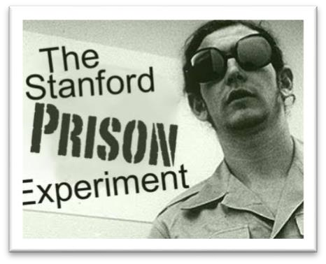
Research and produce a fact sheet on the following three key studies:

- Asch’s (1951 & 1955) conformity study
- Milgram’s (1963) Obedience to Authority
- Zimbardo’s Stanford Prison Experiment

Remember to include the procedure of the experiment (i.e. what they did) the findings and the conclusions of all three experiments.
You can produce a separate fact sheet for each of the experiments.

Reading to help you:

Websites:
- Youtube have a number of really good factual clips. In particular ‘Crash Course’ have produced a number of introductory videos to key elements in Psychology.
- http://www.simplypsychology.org/a-level-psychology.html - Tailored to the old specification, but has all the relevant key information for A Level Psychology.
- http://www.psychteacher.co.uk/ - Tailored to the old specification but contains key information for A Level Psychology.
- http://www.tutor2u.net/psychology - A great website – with specifics of the new specification.

Marvellous Memory…

Mini Experiment:
In this experiment you can test as many or as little people as you like. As the experimenter you should read out one line at a time of the triangle of numbers below to your participant. When you have finished reading out the line, your participant should recite back to you as many of the numbers they can remember. Record how many numbers they recall correctly on each line.

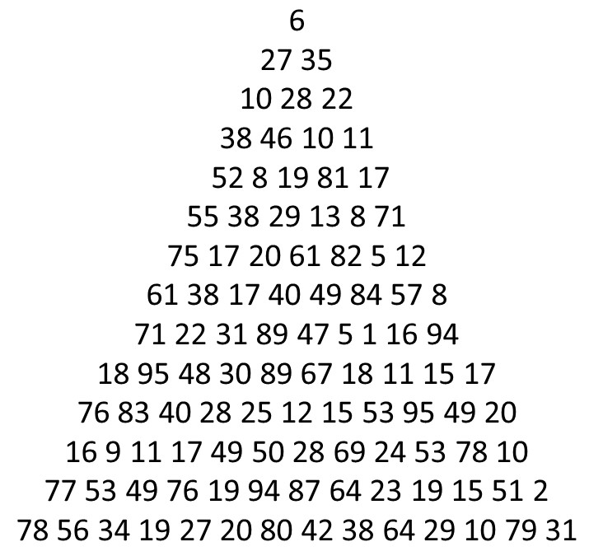
Now think about and explain:
- What was the maximum amount of numbers
your participants call recall from any line? (If you used more than one participant, take the average).
- What do your results suggest about memory?

Now research and answer the following…
1) What is memory? Does it have different types? If so, explain them…
2) What is the capacity and duration of the average memory in humans?
3) What did George Miller do in 1956? What did he discover about memory? How does this link to the results from your experiment above?

Research Methods…

 | Uniform | Non-uniform
No of students who obeyed | 22 | 19
No of students who disobeyed | 8 | 11

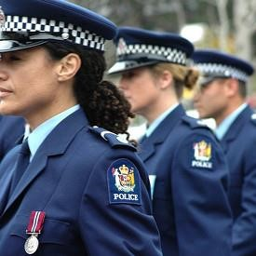
Task 1

This data is taken from an experiment where students were given instructions by someone in uniform or someone not in uniform then it was recorded whether the students obeyed or disobeyed.

- What percentage obeyed in the uniform condition?
- Of the total number of participants tested, what fraction obeyed in the uniform condition?
- Demonstrate the information in the table graphically.

Task 2
This table shows the time taken (seconds) to complete a reasoning task in two different conditions.
Condition A | Condition B
32.38 | 42.73
28.93 | 50.21
34.27 | 43.63
30.41 | 46.25
36.84 | 44.37
34.28 | 45.81
37.11 | 67.32
29.79 | 48.91
37.46 | 41.63
35.58 | 47.79
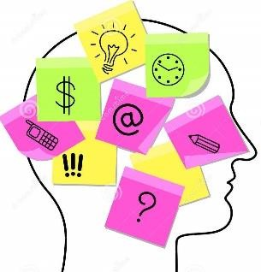
- Rewrite the table giving all the data to the nearest whole number
(2 marks)
- Calculate the mean and the range for each group (3 marks)
- Which type of graphical display would be appropriate to present the results in the table? (1 mark)
- Sketch the graphical display you have identified in your previous answer. (3 marks)

Task 3:
This table shows participants responses to either leading or non-leading questions
- How many participants were there in the leading questions group? (1 mark)
Condition A: Participants answering a leading question |  | Condition B: Participants answering a non-leading question
Yes | No | Yes | No
8 | 2 | 4 | 6
- Calculate the number of participants in the leading questions group as a percentage of the total number of participants.
(1 mark)
- Is the data in the table quantitative or qualitative? Explain your answer. (2 marks)
- Explain one strength and one limitation of this type of data.
(2 + 2 marks)
- Draw a bar chart of the results in the table.
(3 marks)

