REGISTRATION FOR FREE SCHOOL MEALS
Key Stage 2 onwards (Year 3 and above)
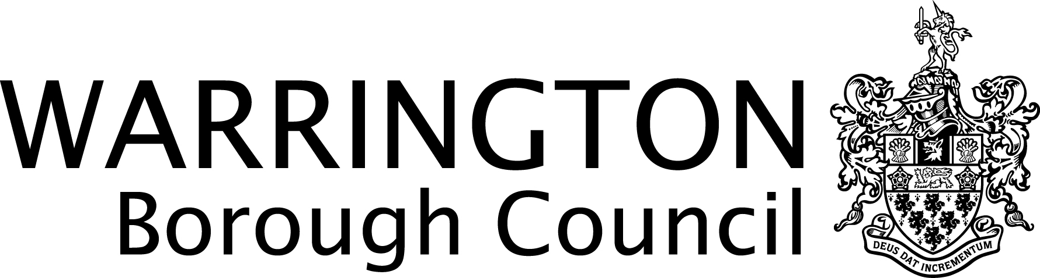

Warrington Borough Council
For office use only
On-Line Eligibility Checked on date _______
By (initial __________
Proof of benefit attached Yes No
Families & Wellbeing Directorate
2nd Floor New Town House
Buttermarket Street
Warrington
WA1 2NH

SECTION 1 – Details of Parent/Carer
Address of Parent/Carer where children live | Mr/Mrs/Miss/Ms | Surname
 | First Names
 | Relationship to child(ren)
 | Telephone Number | Date of Birth

*Are you applying as a foster carer? If yes please see note on back of form. YES NO
SECTION 2 – Details of Person Claiming one of the benefits listed overleaf

First Names | Surname
National Insurance Number | Date of Birth
I confirm that the claimant listed in Section 2 lives at the above address YES NO

SECTION 3 – Children Give the names of each dependent child attending school
First Names | Surname | Sex  M | Sex  F | Date of Birth | School
Section 4 - Declaration
Data Protection
Warrington Borough Council, Schools and Families maintain a database in respect of Education, which relates to the administration of pupils. All personal information provided on this form is treated in strict confidence in accordance with the requirements of the Act. We may verify information you have provided on this form. This could involve contacting your current school or other Council Departments who maintain appropriate records. The data may be shared with other Local Authorities and the Department of Education, external service providers including appropriate agencies for the purpose of provision of services to your child.

I certify that the above information is correct to the best of my knowledge and belief.

Signature: _________________________________________________ Date: __________________________

In order to qualify for Free School Meals the claimant must be in receipt of one of the following:

BENEFIT | PROOF OF BENEFIT
Universal credit (UC)** | Letter or screenshot of entitlement to Universal Credit which must be dated no more than 6 weeks before the date of application.
Income support (IS) | Letter or screenshot of entitlement to Income Support which must be dated no more than 6 weeks before the date of application
Income based job seekers allowance (IBJSA) | Letter or screenshot of entitlement to Income Based Jobseekers allowance which must be dated no more than 6 weeks before the date of application
Child tax credit but only those who are not entitled to a Working Tax Credit* and whose annual income (as assessed by the Inland Revenue) does not exceed £16,190 (subject to annual review), | Tax Credit Award notice as supplied by Inland Revenue for the current tax year  * Tax credit award notice as supplied by the Inland Revenue for the current tax year and proof of the date employment ceased or the date employment of less than 16 hours per week started.
Working Tax Credit run-on | Paid for the four weeks after you stop qualifying for Working Tax Credit
Support under part vi of the immigration and asylum act 1999 | Vouchers as supplied by Inland Revenue.
Guarantee element of state pension credit | Pension Credit Award Notice (M1000)
Income related employment and support allowance (IRESA) | Letter or screenshot of entitlement to Income Related Employment and Support Allowance which must be dated no more than 6 weeks before the date of application
**Universal Credit - if you apply on or after 1 April 2018 your household income must be less than £7,400 a year (after tax and not including any benefits you get)
* Please note foster carers are not entitled to claim free school meals as the fostering allowance includes funds to pay for school meals.
Please return your completed form to: Families & Wellbeing Directorate, 2nd Floor New Town House, Buttermarket Street, Warrington WA1 2NH
or email schooladmissions@warrington.gov.uk For further details telephone 01925 446226

PRIVACY NOTICE
To find out further information about the way that the Council handles your information, please visit: https://www.warrington.gov.uk/privacy_policy

